# 2.1-Testing in the Context of a Software Development Lifecycle

Chapter 2_part 1 - start at 1:36

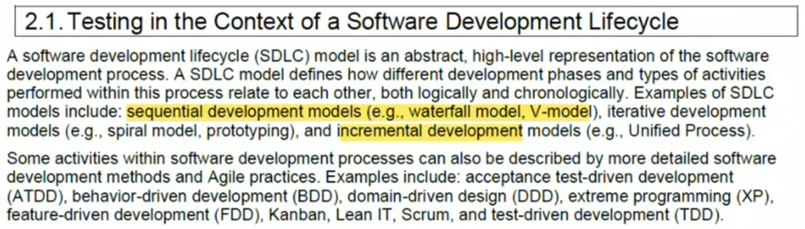

## 2.1.1-Impact of the Software Development LiveCycle on Testing

Chapter 2_part 1 - start at 9:07

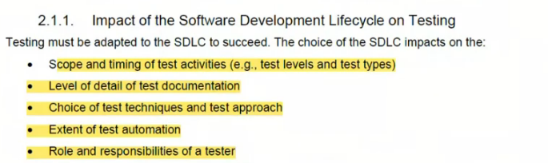

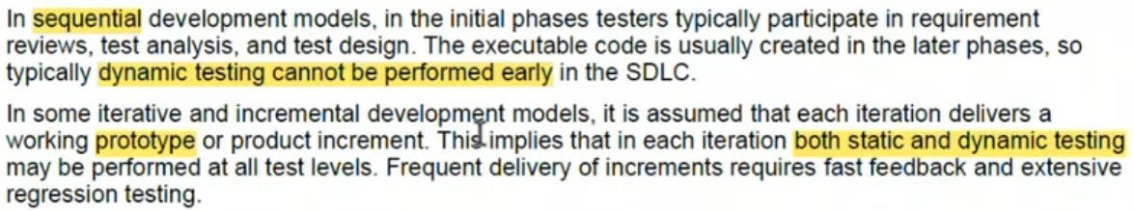

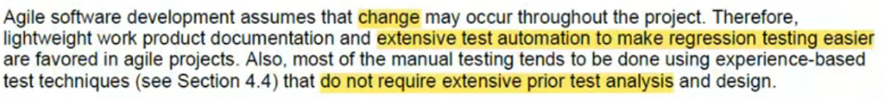

## 2.1.2- Software Development LiveCycle and Good Testing Practices

Chapter 2_part 1 - start at 14:59

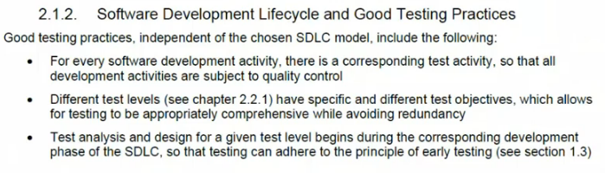

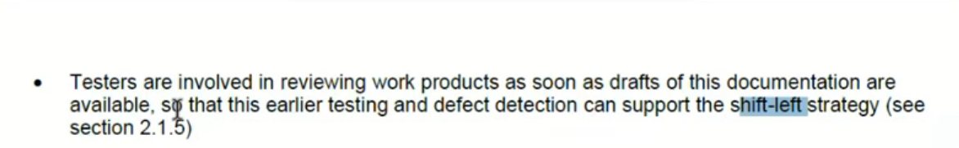

## 2.1.3-Testing as a Driver for Software Development

Chapter 2_part 1 - start at 18:20

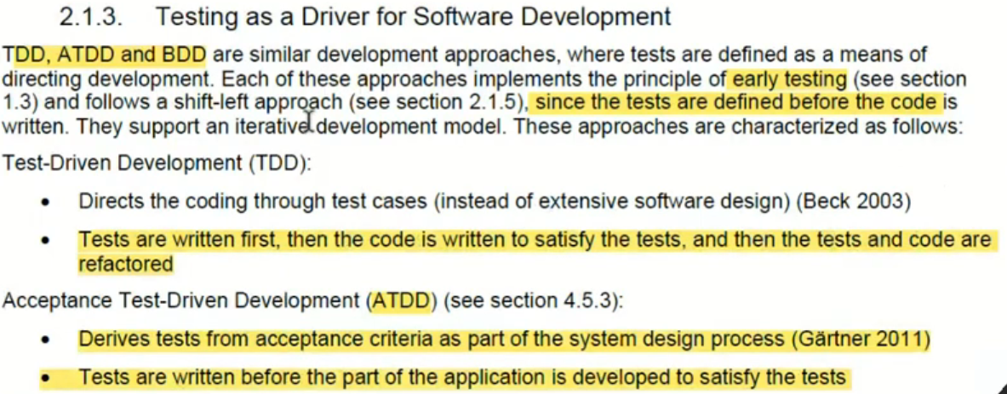

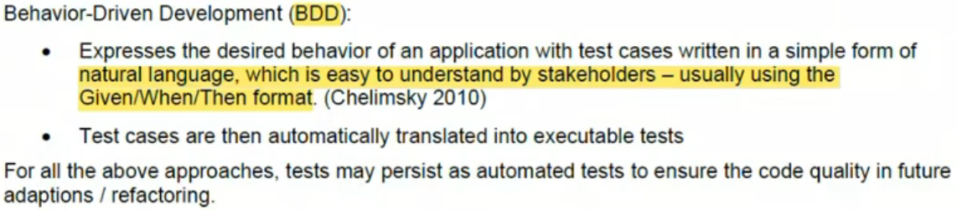

## 2.1.4-DevOps and Testing

Chapter 2_part 1 - start at 27:39

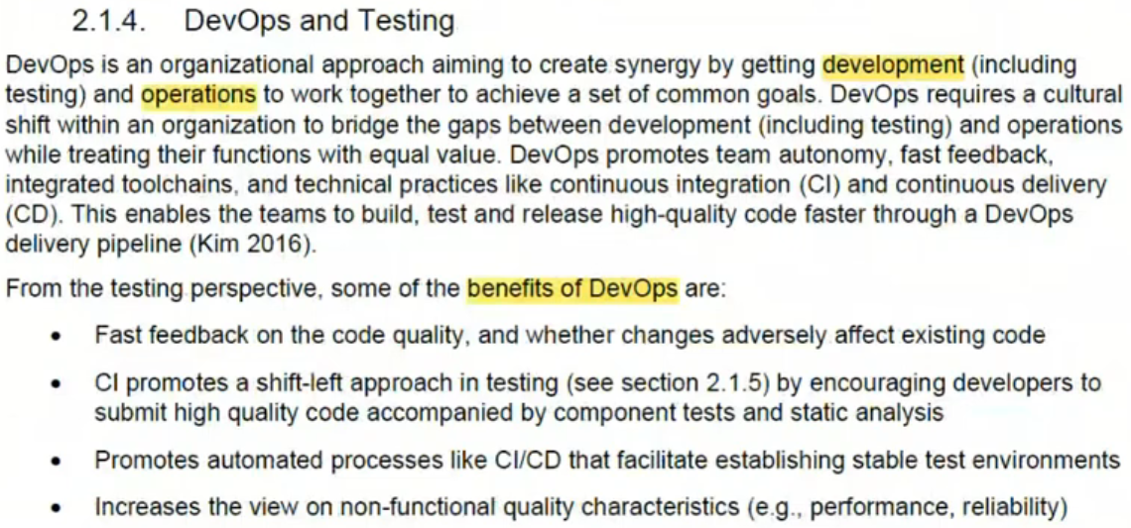

Chapter 2_ part 2 - start at 3:56

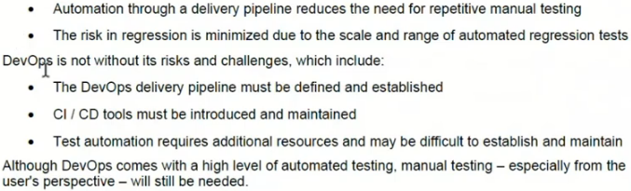

## 2.1.5-Shfit-Left Approach

Chapter 2_ part 2 - start at 5:19

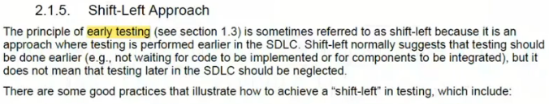

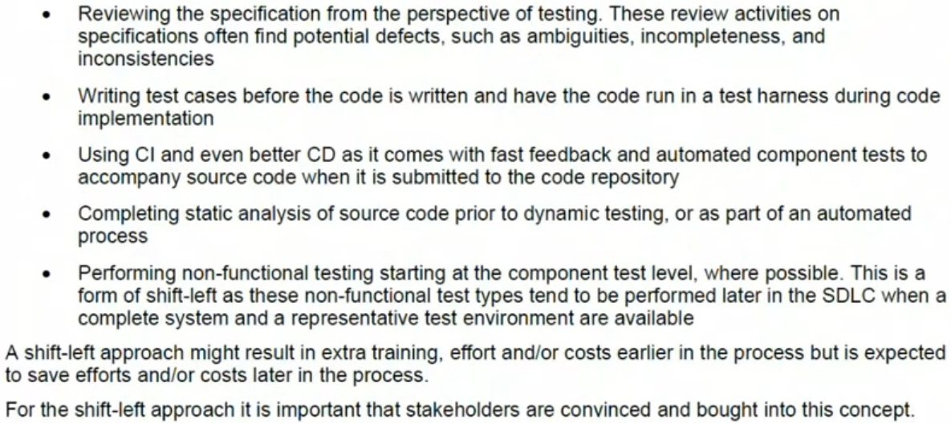

## 2.1.6-Retrospectives and Process Improvement

Chapter 2_ part 2 - start at 8:29

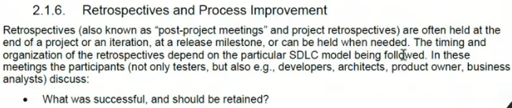

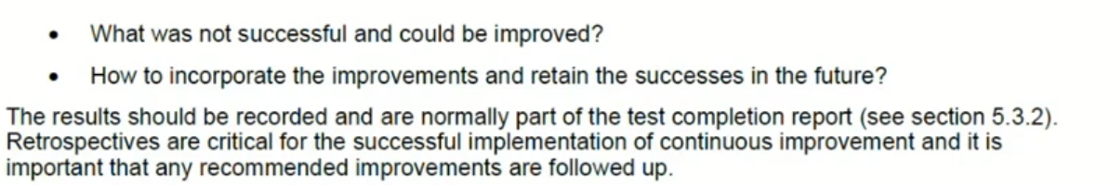

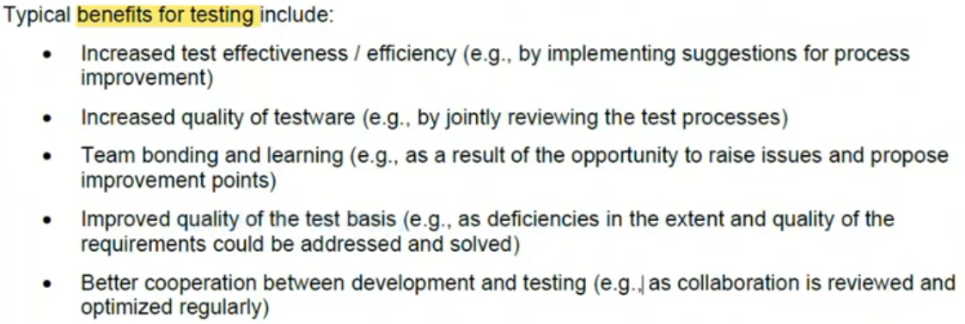

# 2.2-Test Levels and Test Types

Chapter 2_ part 2 - start at 11:27

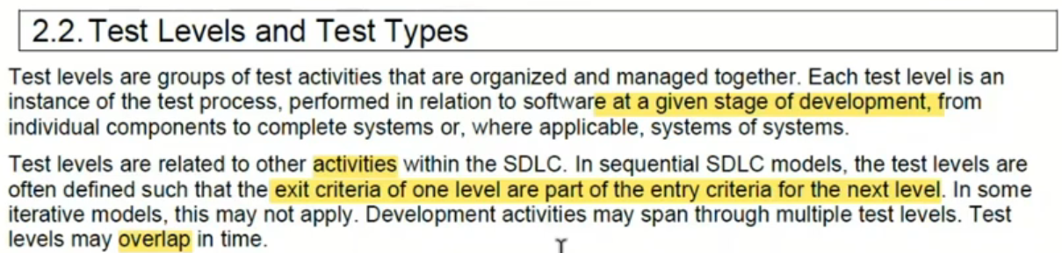



## 2.2.1-Test Levels

Chapter 2_ part 2 - start at 13:32

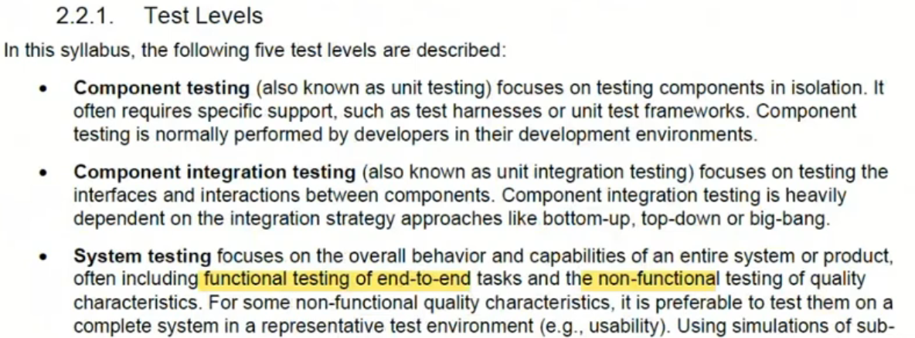

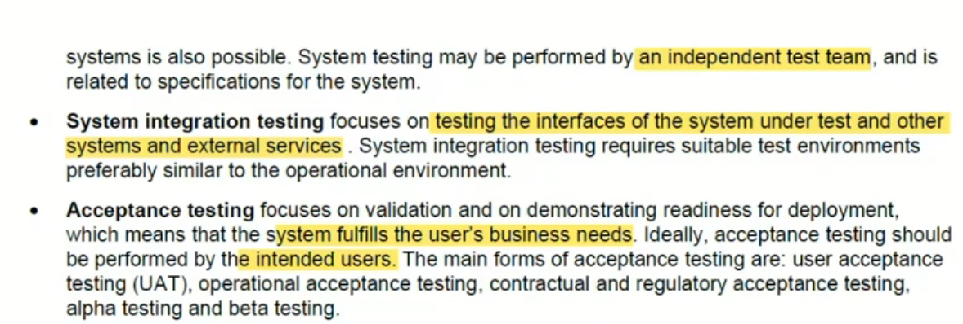

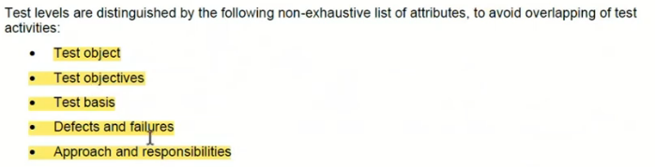

## 2.2.2-Test Types

Chapter 2_ part 2 - start at 17:27

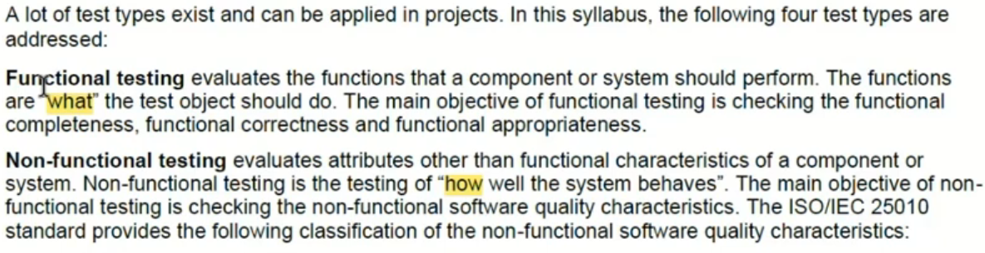

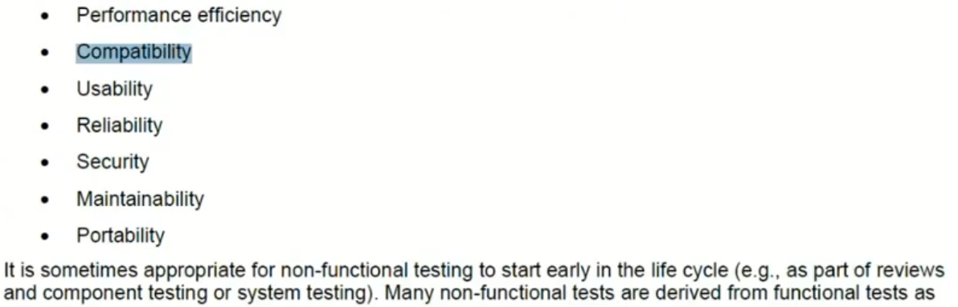

## 2.2.3-Confirmation Testing and Regression Testing

Chapter 2_ part 2 - start at 20:41

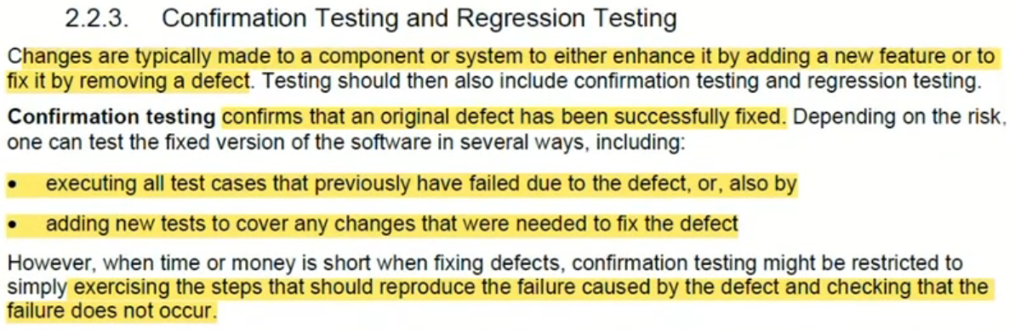

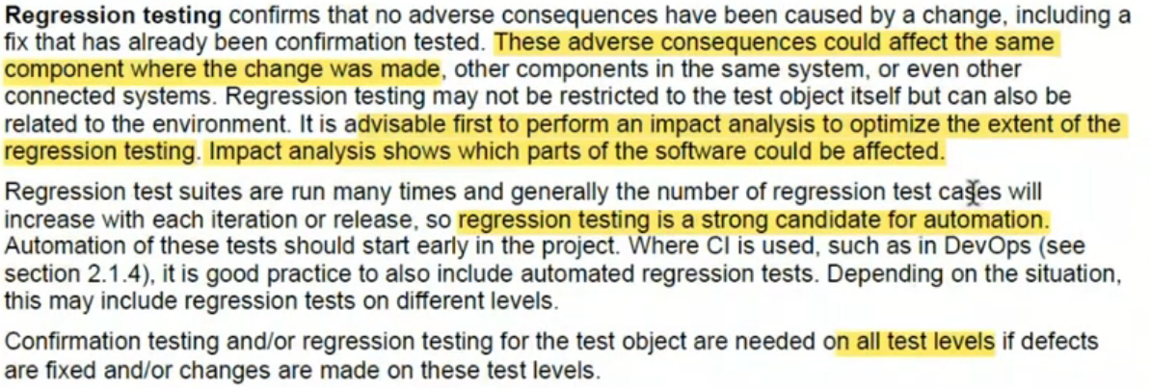

# 2.3-Maintenance Testing

Chapter 2_ part 2 - start at 23:18

